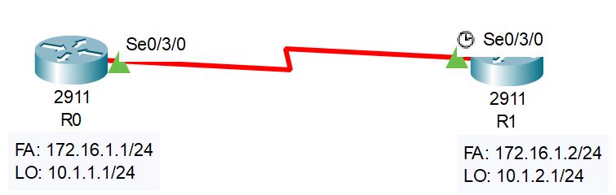

**Router R0**:

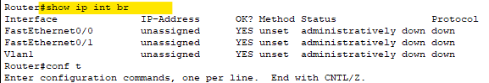

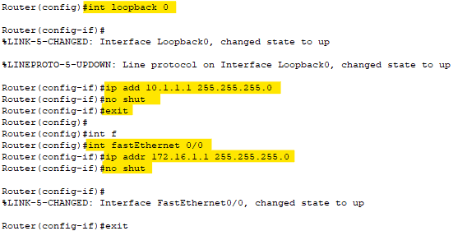

**Router R1**:

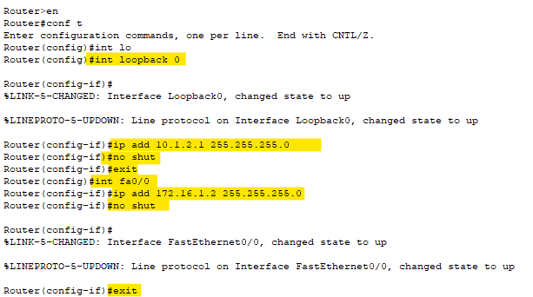

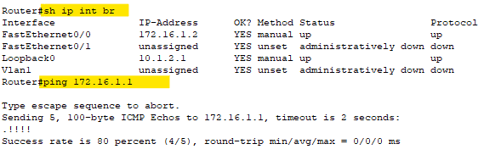

Checking **Encapsulation: HDLC**

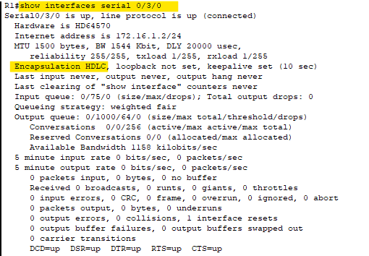

**Converting the link to PPP encapsulation on R0 & R1:**

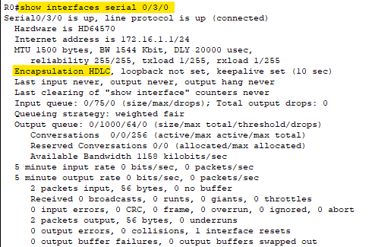

**Changing the “Encapsulation”**

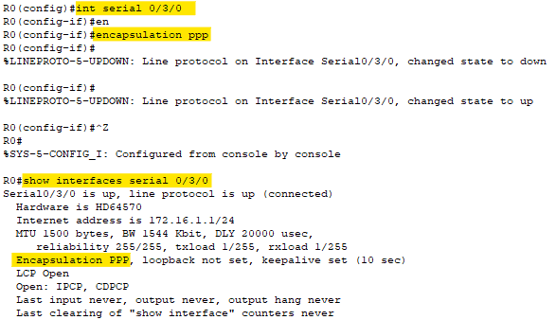

**CDP neighbours on R0:**

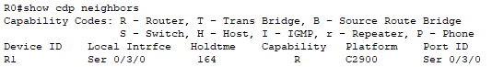

**CDP neighbours on R1:**

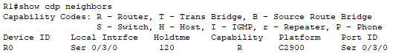

**PPP Authentication: Router R0**

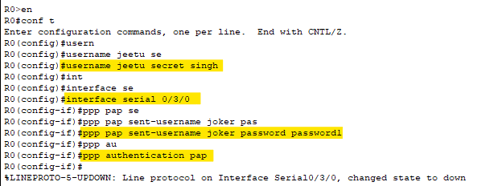

**Enabling PAP on R0:**

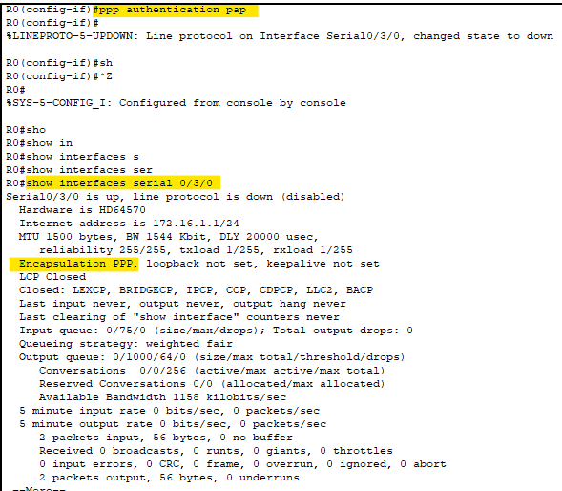

**Go to Router R1:**

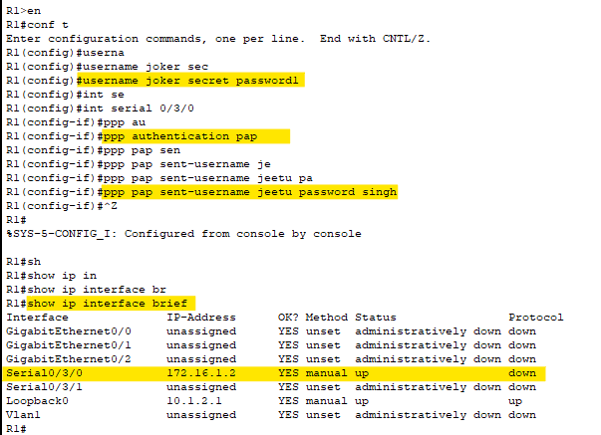

**After few seconds:**

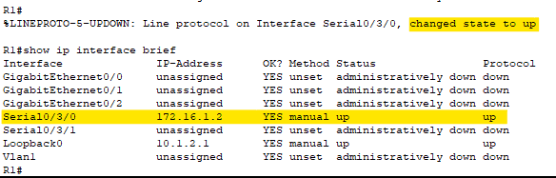

**Converting current scenario to use PPP-CHAP authentication:**

* Wither PAP or CHAP can be configured at a time.

**Router R0:**

# conf t

(config) # username Jeetu password 12345

(config) # int ser 0\3\0

(config) # ppp authentication chap

**Router R1:**

# conf t

(config) # username Jeetu password 12345

(config) # int ser 0\3\0

(config) # ppp authentication chap